**Gyro & Accelerometer Sensor Report (Plane Simulator) on the basic project using Arduino and Processing s/w.**

Intro:

* This project (Plane Simulator) is to study and experienced on how to implement the gyro and accelerometer into the real life situation.
* Image snip below show the 2d circuit connection design consist of:
* Jumper female to male x5
* Mpu6050 accelerometer & gyro
* Arduino Uno R3
* The Pin Connection:
* Vcc - 5V
* GND -­ Gnd
* Sda - A4
* Sdc -A5
* INT - D2

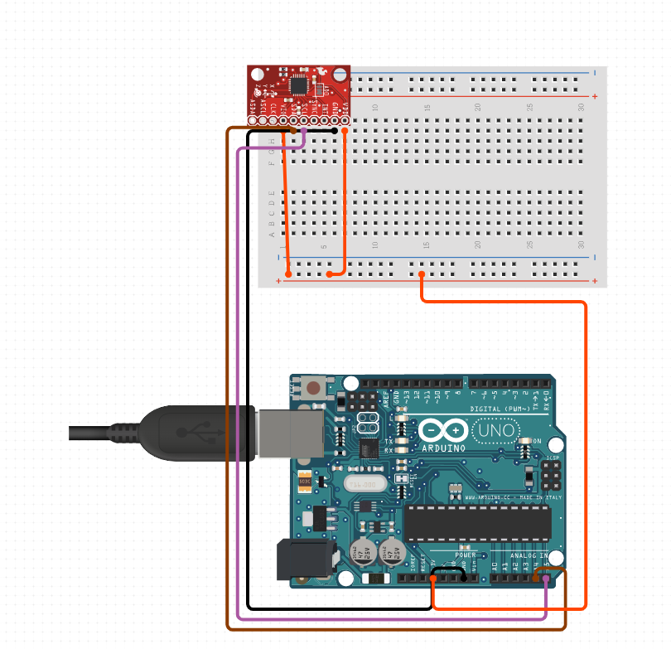

* Connect the Arduino board to the PC.
* Install I2CDEV and MPU6050 library .
* Insert the Code in Arduino IDE (Integrated Development Environments) on link below:

[MPU6050-Sensor/MPU6050_AKIM.ino at main · akimaziz/MPU6050-Sensor (github.com)](https://github.com/akimaziz/MPU6050-Sensor/blob/main/MPU6050_AKIM.ino)

* Please make sure to install the library first before run the program.
* After Install, proceed to upload process.
* Exit the Arduino IDE application in the windows.
* Next, open the processing 4.2 IDE and download a few library for the simulation plane shape:
* toxiclib_p5
* toxiclibscore
* C:\Users\user\Documents\Processing\libraries

(ALL STEP IS NOT 100% DETAIL, try to search and discover by yourself)

* Run the Code!

